Application of Lyapunov Stability to Adaptive Control

Theory Required for MRAC Simulink Example
Written November 2004

For more information refer to: Slotine and Li “Applied Nonlinear Control”

In model-reference adaptive control, the control law is continuously adapted, to drive the response of process close to that of a reference model.

Consider we have the simple first-order system, where the process parameters a_{p} and b_{p} are unknown. We however do know the sign of b_{p}.

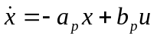

We propose the following tracking control-law, (with time-varying gains),

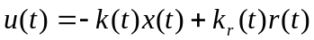

The closed loop dynamics are then given by the nonlinear equation;

Consider that we wish the closed-loop process to behave like the reference model,

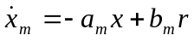

This could be easily achieved by choosing gains,

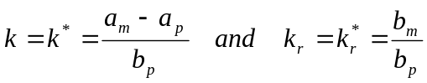

We will now define the following three errors that describe how far away the closed-loop performance is away from the reference model.

We will propose the candidate Lyapunov function,

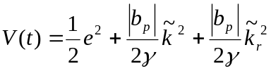

Which is globally positive definite, with V=0, corresponding to perfect convergence of the closed-loop system to the reference model.
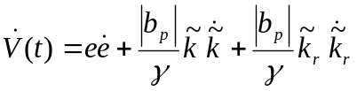
But we could write,

Using x_{m}=x-e, we get the following error dynamic equation

We will now use the relationships for the gains;

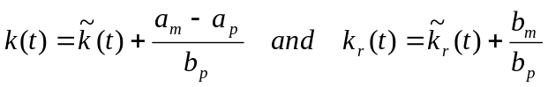

There tracking error dynamic equation simplifies to;

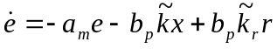

Hence substituting into equation for 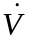yields,

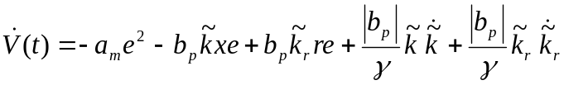

Now we know that: 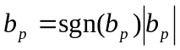

If we choose the following adaptive-laws for the gains;

then; 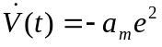

This is negative definite, hence the tracking error e converges to zero.

The gains can be determined by integration:

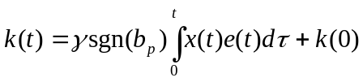 and 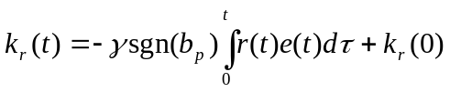

This MRAC controller could be constructed as:

x_{m}(t)
x_{m}(t)
r(t)
Reference
model
e(t)
x_{m}(t)

u(t)
x_{m}(t)
x(t)
x_{m}(t)
+
+
Plant
*

*
k_{r}(t)
x_{m}(t)
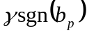
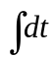
*

k(t)
x_{m}(t)
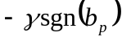
*

Example: Consider the first order plant, under closed-loop control:

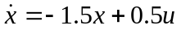 with 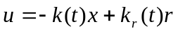

We wish it to follow the reference model 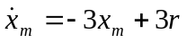

The correct choice of the gains are: 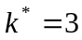, 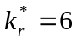

We do not have accurate parameters and we make the choice, 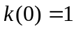and 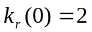

The attached plots show how the gains converge over time and how the plant state x converges to the reference model, for γ =1, 10 and 50, for this specified plant and reference model.

NB: A Simulink demonstration “mrac.mdl”of this simple Model-Reference Adaptive Controller is available on elecad/public/ee4002/simulink/lyapunov

You need to specify your reference model parameters a_{m} and b_{m}, your plant parameters a_{p} and b_{p} and the adaptation gain γ.

Graph of how process state x converges to the reference model state x_{m} for γ=1, 10, 50

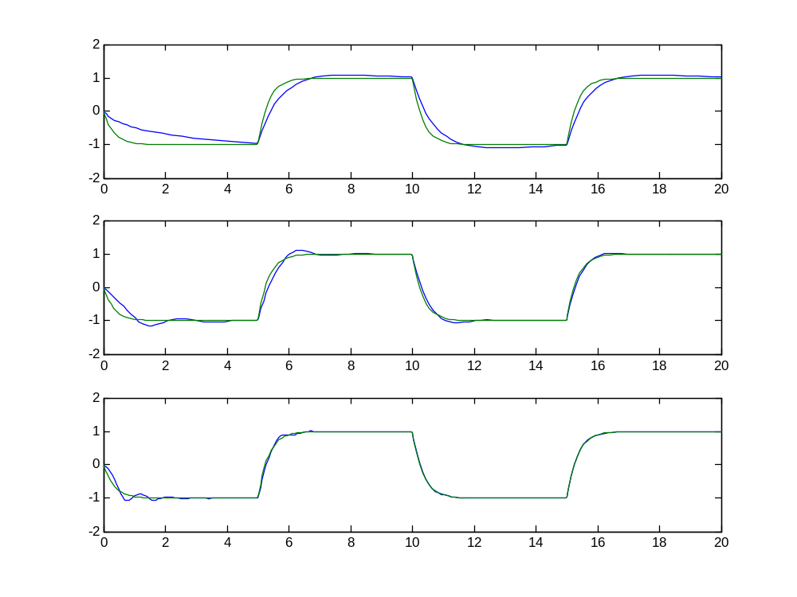
x
time (seconds)
γ=10
γ=50
γ=1
Graph of how the controller gain k(t) and k_{r}(t) evolve for γ=1, 10, 50

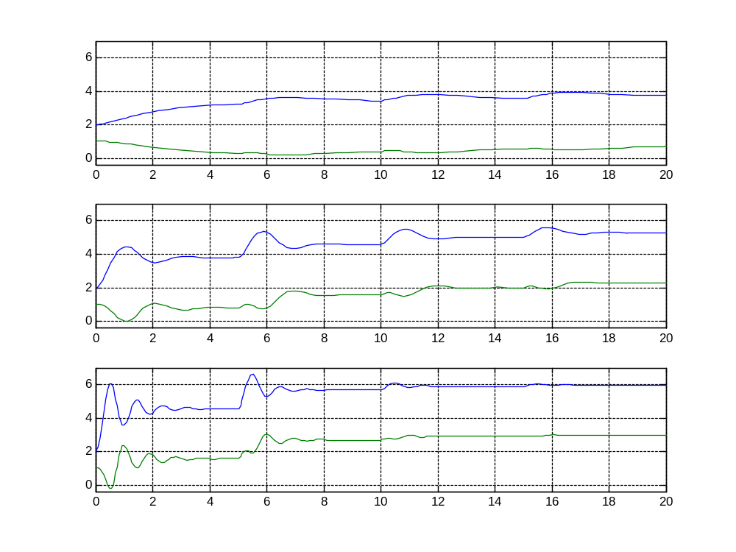
γ=1
time (seconds)
γ=10
γ=50
k_{r}

